SECTION 1: CONTENTS OF THE REPLICATION DOCUMENTATION

Folder 1: Original Data
- Includes the original data file from the SWAN study in Visit 10 (2006-2008). Named “Original SWAN dataset”
- Also includes the importable data file for R studio. Named “swan.csv”

Folder 2: Analysis Data
- Includes the cleaned data set that has omitted missing values. Named “analyticdataset.csv”

Folder 3: Documents
- Includes the final paper describing background literature, methods, results, and implications of the study.
- Includes the data dictionary, titled “Data Dictionary_Koala Care”. This document provides a description of the original code name, natural language, survey description, and role (outcome, exposure, or confound) for each variable included in the analysis.
- Includes the “Read-Me File”. This document contains 3 sections: the contents of the replication documentation (section 1) and instructions for replicating the study (section 2).
  - We were able to download the original SWAN data set from the Internet, so we did not include a section for modifications made to the importable data file.

Folder 4: Command Files
- This file includes the complete R script that we used to conduct the study including factoring variables, removing missing data, and conducting the logistic regression.

SECTION 2: INSTRUCTIONS FOR REPLICATING THE STUDY

Step 1: Open R Studio
Step 2: Open “Koala Kare Project Code.rmd” from Command File folder (4)
Step 3: Click on the folder button with a green arrow in it on the right side of the R-studio window in the red circle below and import the data set called “Original Swan Dataset”
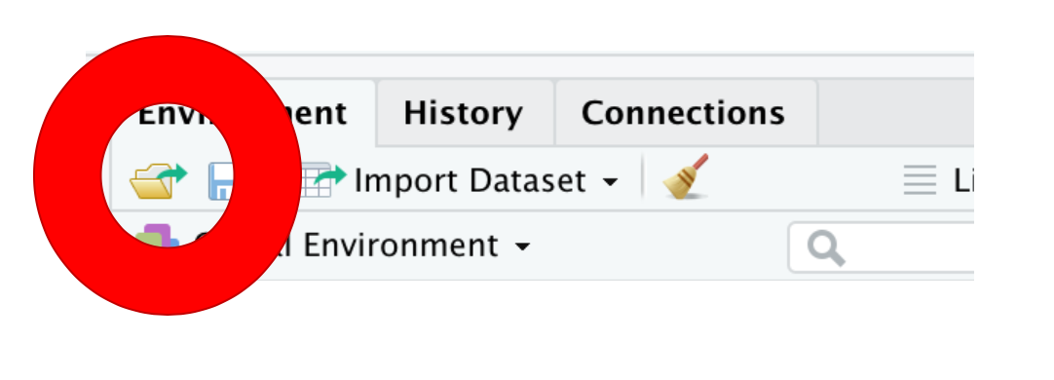
Step 4: Check that the code to rename the data to “swan” lines up with the number “da32961.0001” That should now be in your global environment
Step 5: Run chunk 1 - this should import and rename the data
Step 6: Run chunk 2 - this should clean the data and create a new subsetted clean data set to work with
Step 7: Run chunk 3 - this should produce descriptive statistic results similar to those found in Table 1 in each of the insight reports given in folder 3
Step 8: Run chunk 4 - this should produce inferential statistic results similar to those found in Table 2 in each of the insight reports given in folder 3

